RH-ISAC Summit: Speaker Marketing Kit

SOCIAL MEDIA PROMOTION

To help promote the RH-ISAC Cyber Intelligence Summit, please use the sample text below to showcase the event on your LinkedIn and/or Twitter profiles.

Join me from April 13 – 15 for the 2026 RH-ISAC Cybersecurity Summit in Austin! I’ll be sharing [key takeaways from session]. Register at https://summit.rhisac.org. Looking forward to seeing you in April!

Tag RH-ISAC in your post:
- Twitter: @RH_ISAC
- LinkedIn: @Retail & Hospitality ISAC

Add hashtags:
- #RHISACSummit
- #ProtectAsOne
- Any other hashtags related to your presentation

Graphic:
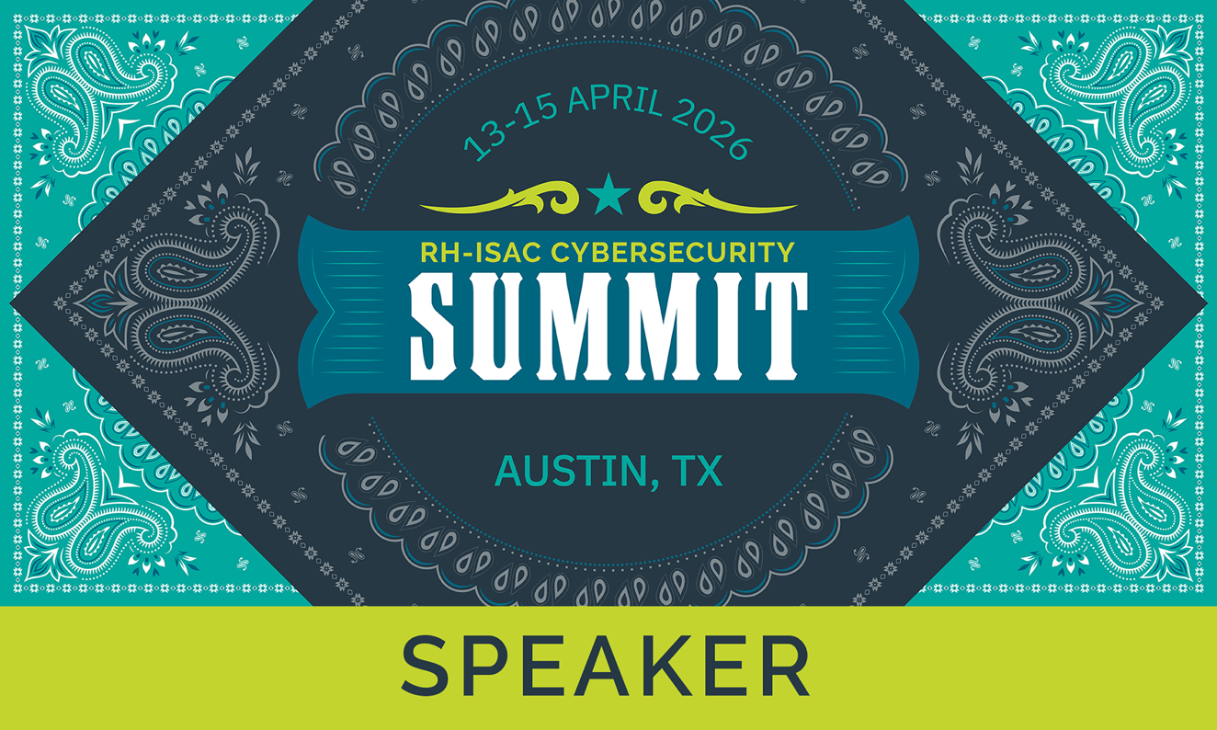

sample press release

To help promote the RH-ISAC Cybersecurity Summit, please feel free to use the below template as a starting point for writing a press release about the event.

[Company Name] Partners with the Retail and Hospitality to Showcase [Presentation Topic]

[City, State (Month XX, Year)] – [COMPANY NAME] today announced that it will partner with The Retail & Hospitality Information Sharing and Analysis Center (RH-ISAC) to help businesses throughout the retail, hospitality, and travel industries take advantage of the company’s [service related to presentation topic].
On April {13, 14 or 15}, [speaker name and title] will give a presentation on [presentation topic]. The session is a part of the RH-ISAC’s Cybersecurity Summit, which brings together information security professionals who work in retail, hospitality, or other consumer-facing businesses for networking and education with peers from around the world.
[Insert a paragraph about the presentation]
The Summit is open to any cybersecurity practitioner that works in the consumer-facing sector. Registration is required. Visit https://summit.rhisac.org for more information.
###
About Company
[INSERT COMPANY BOILERPLATE]
About RH-ISAC
The Retail & Hospitality Information Sharing and Analysis Center (RH-ISAC) is the trusted community for sharing sector-specific cybersecurity information and intelligence. The RH-ISAC connects information security teams at the strategic, operational, and tactical levels to work together on issues and challenges, to share practices and insights, and to benchmark among each other – all with the goal of building better security for the retail, hospitality, and travel industries through collaboration. RH-ISAC serves all retail, hospitality, and travel companies, including retailers, restaurants, hotels, gaming casinos, food retailers, consumer products, and other consumer-facing companies. For more information, visit www.rhisac.org.

SAMPLE blog

To help promote the RH-ISAC Cyber Intelligence Summit, please feel free to use the below template as a starting point for a blog post on your company blog to promote the event.

Writing Your Blog:

- Your blog post should provide educational value on the topic that you will be presenting on, with the call to action of learning more about this topic by registering for the Summit.

Sample Blog Format:

Blog Title: Informative title, around 60 characters
Blog Description: 155-165 character description of the post

Paragraph 1: Introduce the topic. Provide background on why the topic is of value to the retail and hospitality cybersecurity community.
Paragraph 2-3: Share some high-level information about the key areas that will be discussed. Don’t go into the nitty gritty details but provide enough of a teaser on the topic to peak readers’ interest.
Paragraph 4: To learn more about {Insert topic}, register for the RH-ISAC Cyber Intelligence Summit on April 7-9 in St. Louis. We’ll be discussing in more detail {key takeaways they can obtain from attending}.

